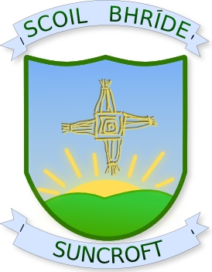
Scoil Bhride, St. Brigid’s N.S.
Crochta na Greine, Suncroft,
Currach, Curragh,
Co. Cill Dara. Co. Kildare
R56 NR27 R56 NR27
Guthan:045/441041 Phone: 045/441041
Principal: Deputy-Principal:
Mr. John Goff Ms. Louise Carroll
Roll Number: 18031k
¯¯¯¯¯¯¯¯¯¯¯¯¯¯¯¯¯¯¯¯¯¯¯¯¯¯¯¯¯¯¯¯¯¯¯¯¯¯¯¯¯¯¯¯¯¯¯¯¯¯¯¯¯¯¯¯¯¯¯¯¯¯¯¯¯¯¯¯¯¯¯¯¯¯¯¯¯¯¯¯¯¯¯¯¯¯¯¯¯¯¯¯¯¯¯¯¯¯¯¯¯¯¯¯

SCHOOL CALENDAR 2020 - 2021

School re-opens Thursday 27th of August

Halloween Mid-Term 26th October – 30th October
School re-opens Monday 2nd November

Christmas Holidays Tuesday 22nd of December
School re-opens Wednesday 6th January

Mid-term break Monday 15th – Friday 19th of February
School re-opens Monday 22nd February

St. Patrick’s Day School closed on Wednesday 17th of March

Easter Holidays Friday 26th of March
School re-opens Monday 12th of April

May Bank Holiday Monday 3rd and Tuesday 4th of May
School re-opens Wednesday 5th of May

June Bank Holiday School closed on Monday 7th of June

Summer Holidays Friday 25th of June

Web site: www.suncroftns.ie Email: suncroftns@gmail.com

