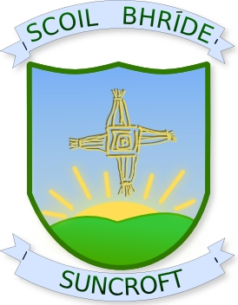
Scoil Bhride, St. Brigid’s N.S.
Crochta na Greine, Suncroft,
Currach, Curragh,
Co. Cill Dara. Co.Kildare.
Guthan: 045/441041 Phone: 045/441041
Fax: 045/442417 Fax: 045/442417

Principal: Deputy Principal:
Mr. John Goff Ms. Louise Carroll
Roll Number: 18031k
¯¯¯¯¯¯¯¯¯¯¯¯¯¯¯¯¯¯¯¯¯¯¯¯¯¯¯¯¯¯¯¯¯¯¯¯¯¯¯¯¯¯¯¯¯¯¯¯¯¯¯¯¯¯¯¯¯¯¯¯¯¯¯¯¯¯¯¯¯¯¯¯¯¯¯¯¯¯¯¯¯¯¯¯¯¯¯¯¯

Policy No: 36 HEALTHY EATING POLICY Rev: 3

Suncroft National School encourages parents to give nourishing lunches to their children.

We ask parents to give their children a lunch that will endeavour to promote healthy teeth and bones and a calm, well nourished body and mind.

The following is a list to clarify what is and is not an acceptable Healthy Lunch:

Allowed Not Allowed
Any and all types of sandwiches Sweets/lollies
Crackers Cakes/buns/muffins
All fruit Chocolate coated bars/biscuits
Popcorn Crisps of all types
Cereal bars Cereal bars with sweets embedded in Rice cakes them
Cereal in a container
Cheese
Cold meats/fish
Yoghurts/Frubes
Plain biscuits e.g.
Digestive/Rich Tea
Croissants
Salads/Pasta

Beverages Beverages
Water All fizzy drinks
Juices/Milk All isotonic/energy drinks
Dilutes squashes
Actimel Drinks

